**ACT**



Mata Praktikum : GOLANG INTERMEDIET

Kelas : 3IA20

Praktikum ke- : 4

Tanggal : 4 November 2022

Materi : (HTTP Request Pada Golang)

NPM : 50420900

Nama : Muhammad Reza Hidayat

Ketua Asisten :

Nama Asisten :

Paraf Asisten :

Jumlah Lembar :



**LABORATORIUM TEKNIK INFORMATIKA**

**UNIVERSITAS GUNADARMA**

**2022**

1. LISTING PROGRAM

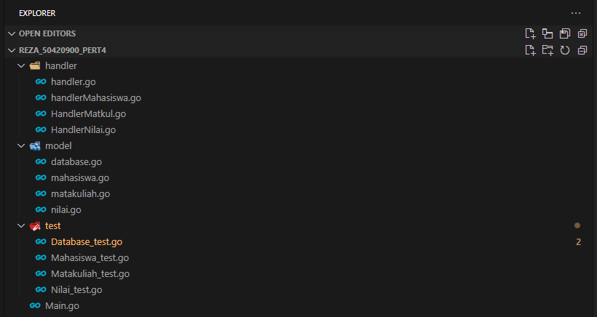

**Main.go**

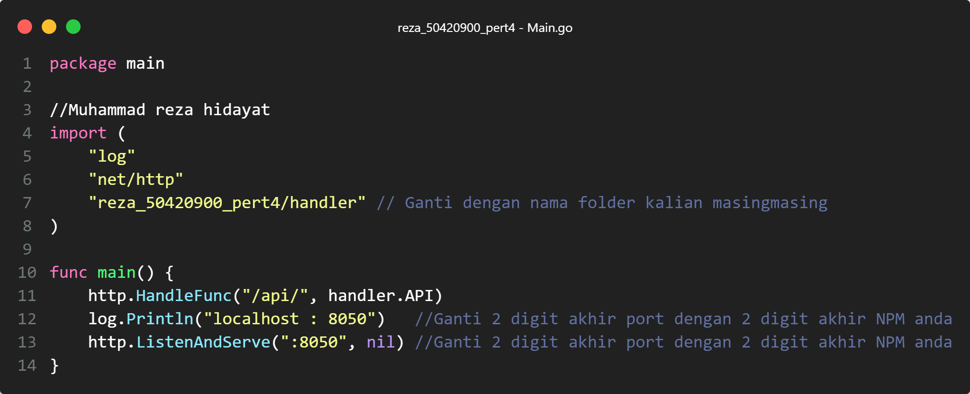

**handler.go**

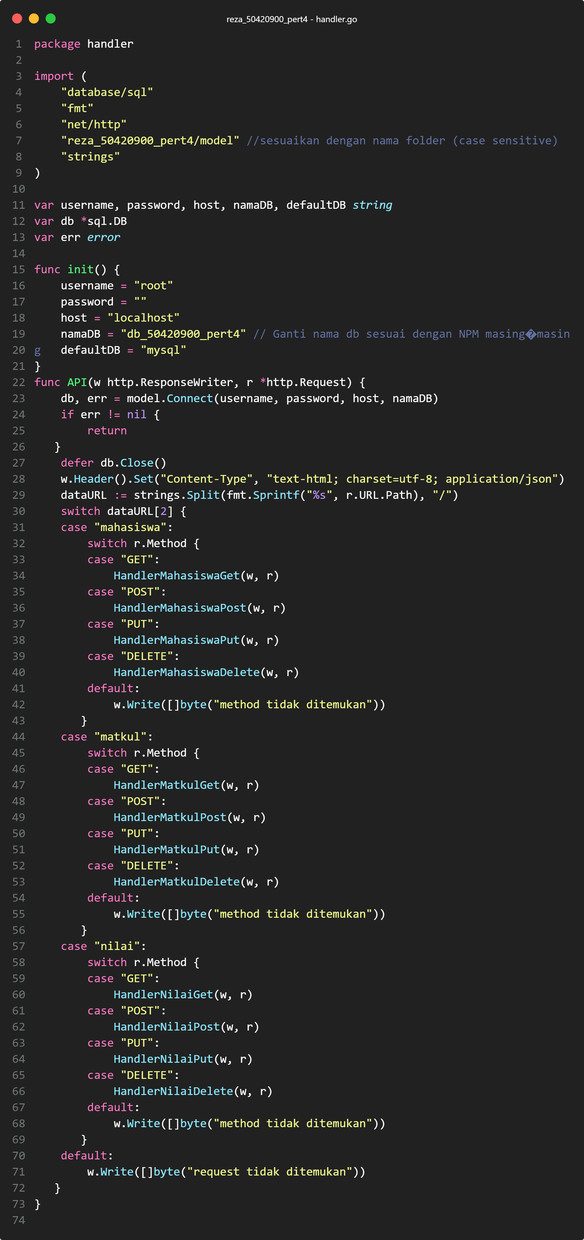

**handlerMahasiswa.go**

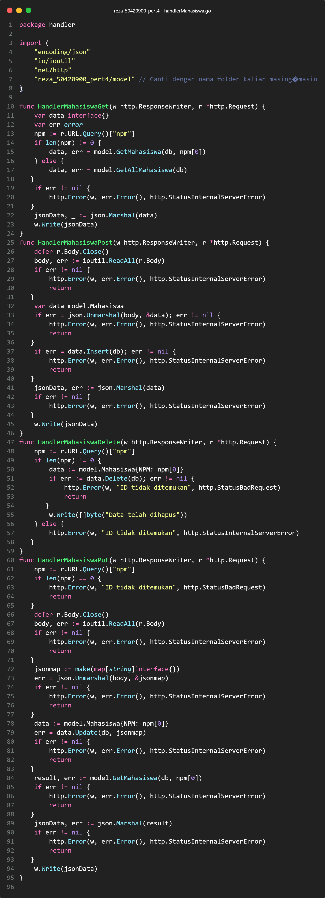

**HandlerMatkul.go**

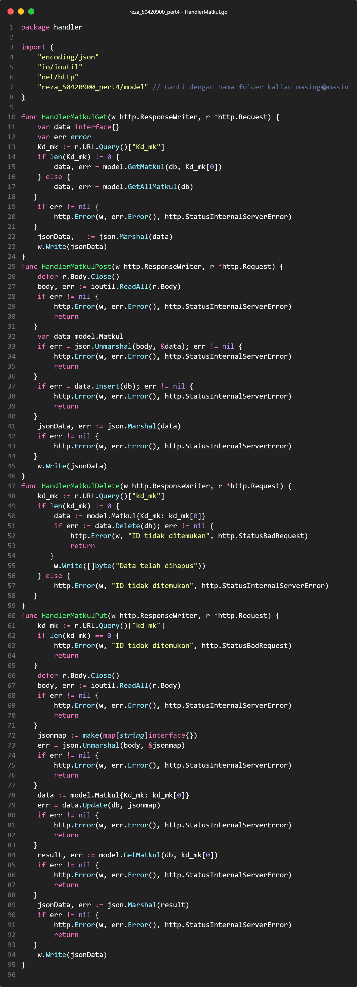

**HandlerNilai.go**

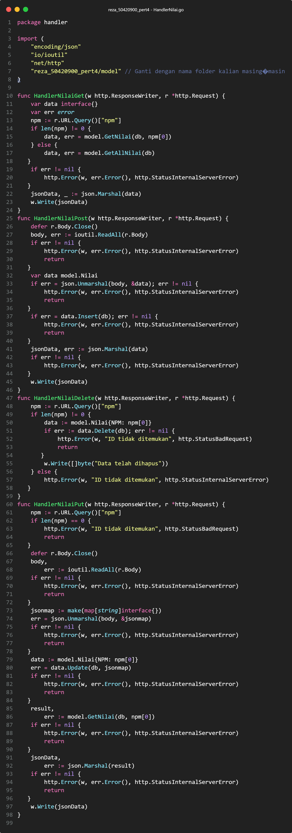

**database.go**

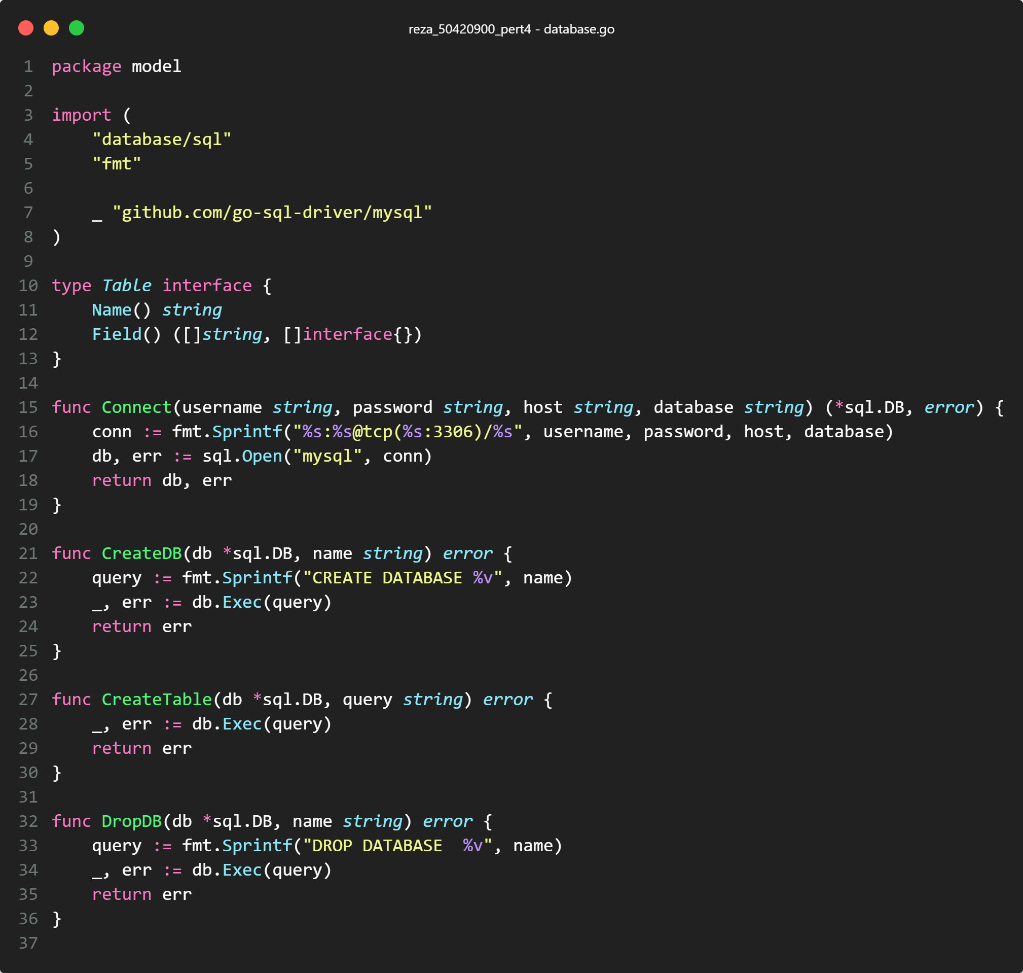

**mahasiswa.go**

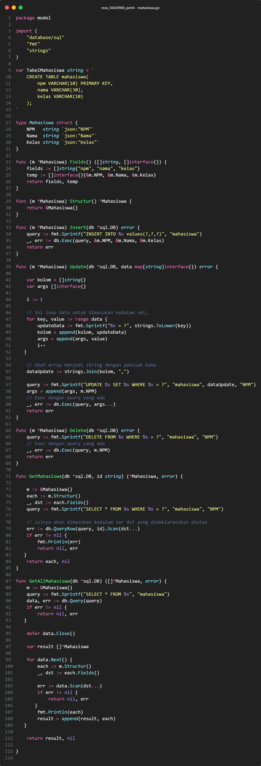

**matakuliah.go**

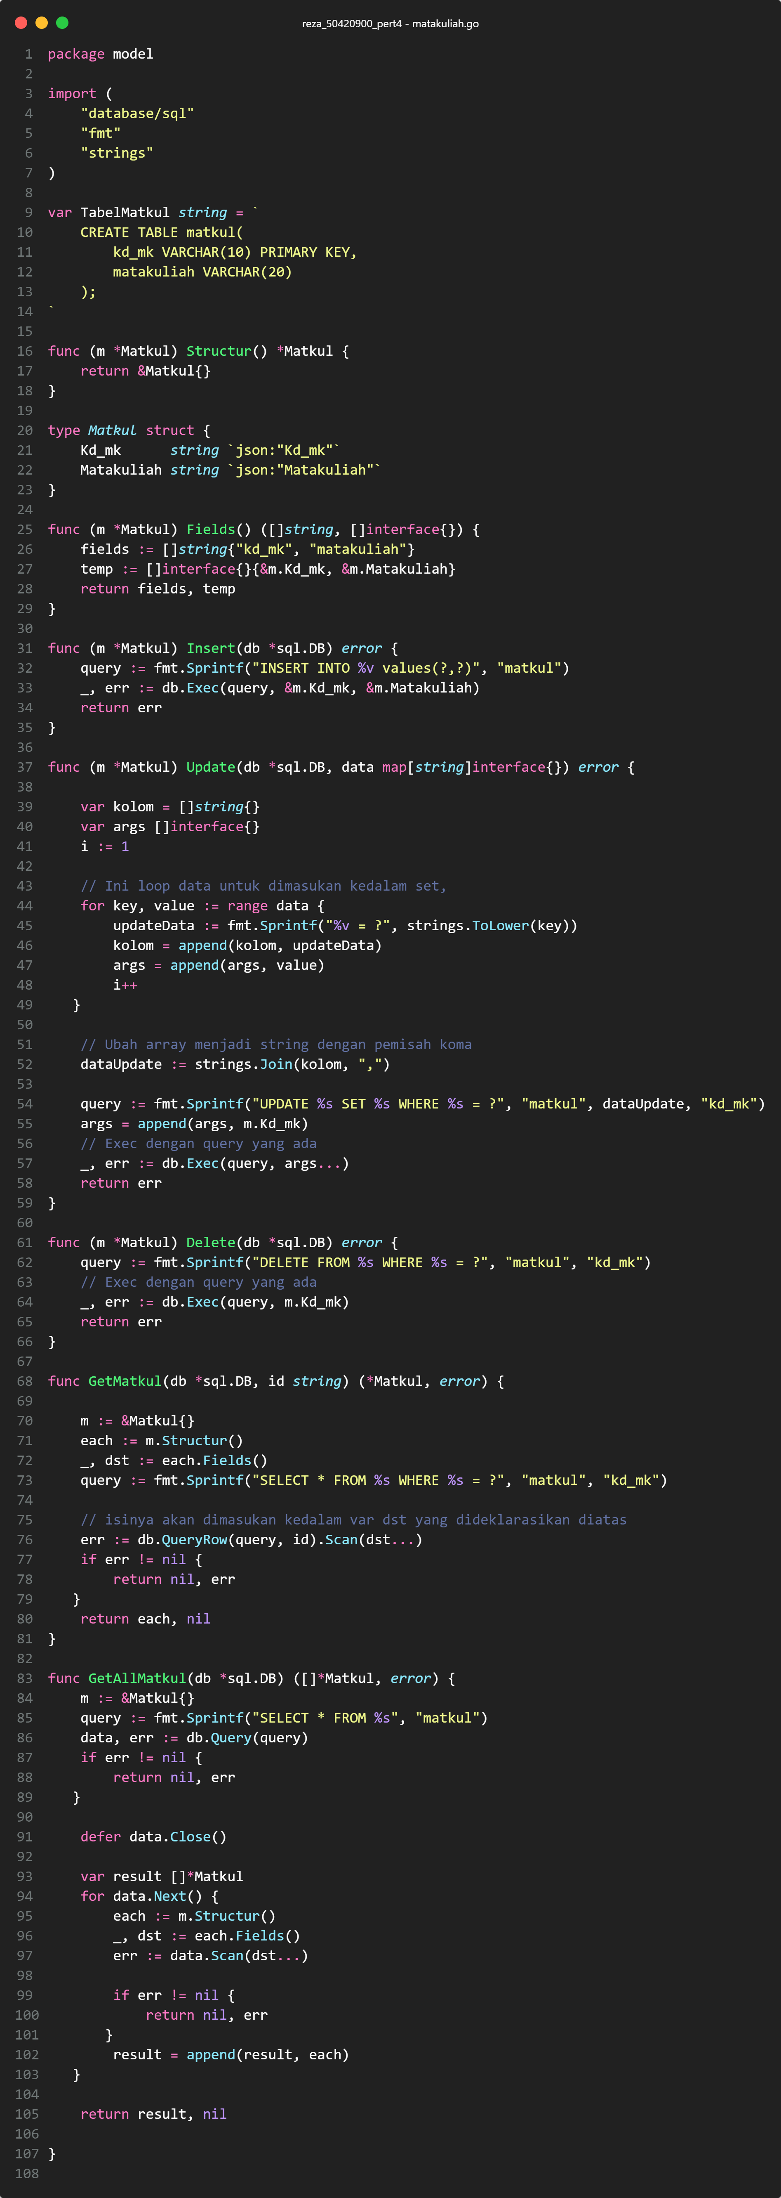

**nilai.go**

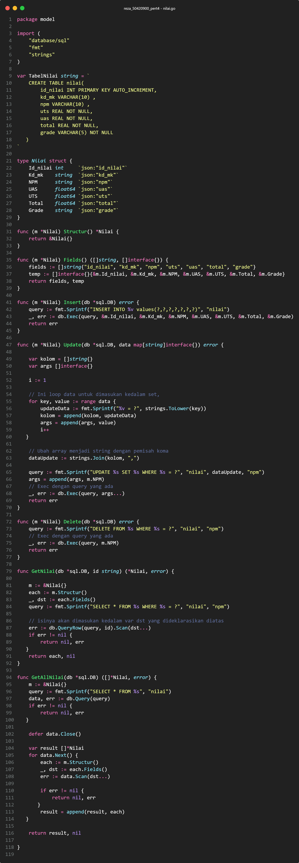

**Database_test.go**

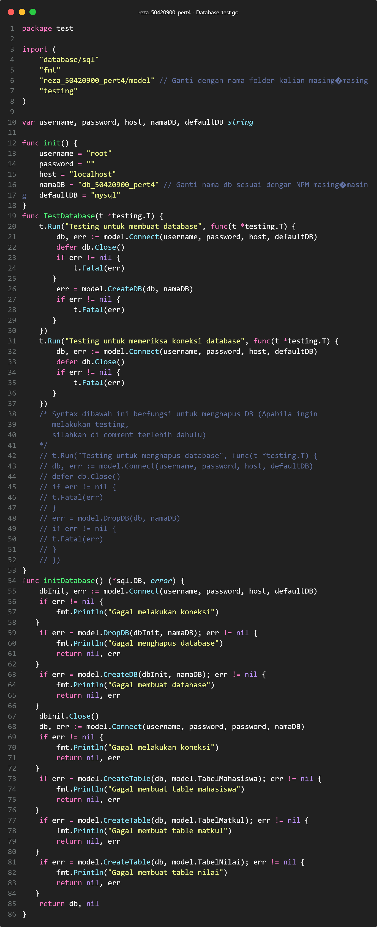

**Mahasiswa_test.go**

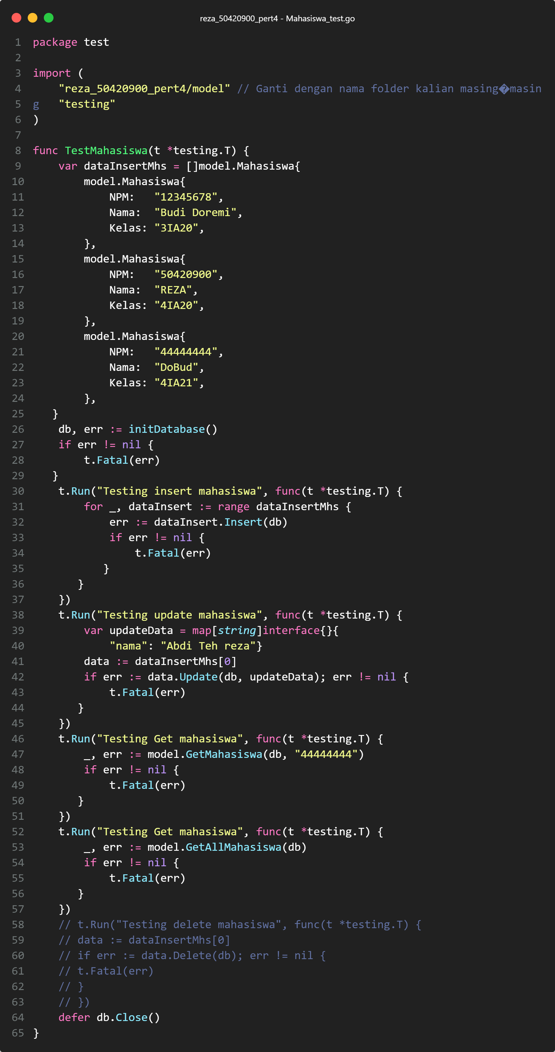

**Matakuliah_test.go**

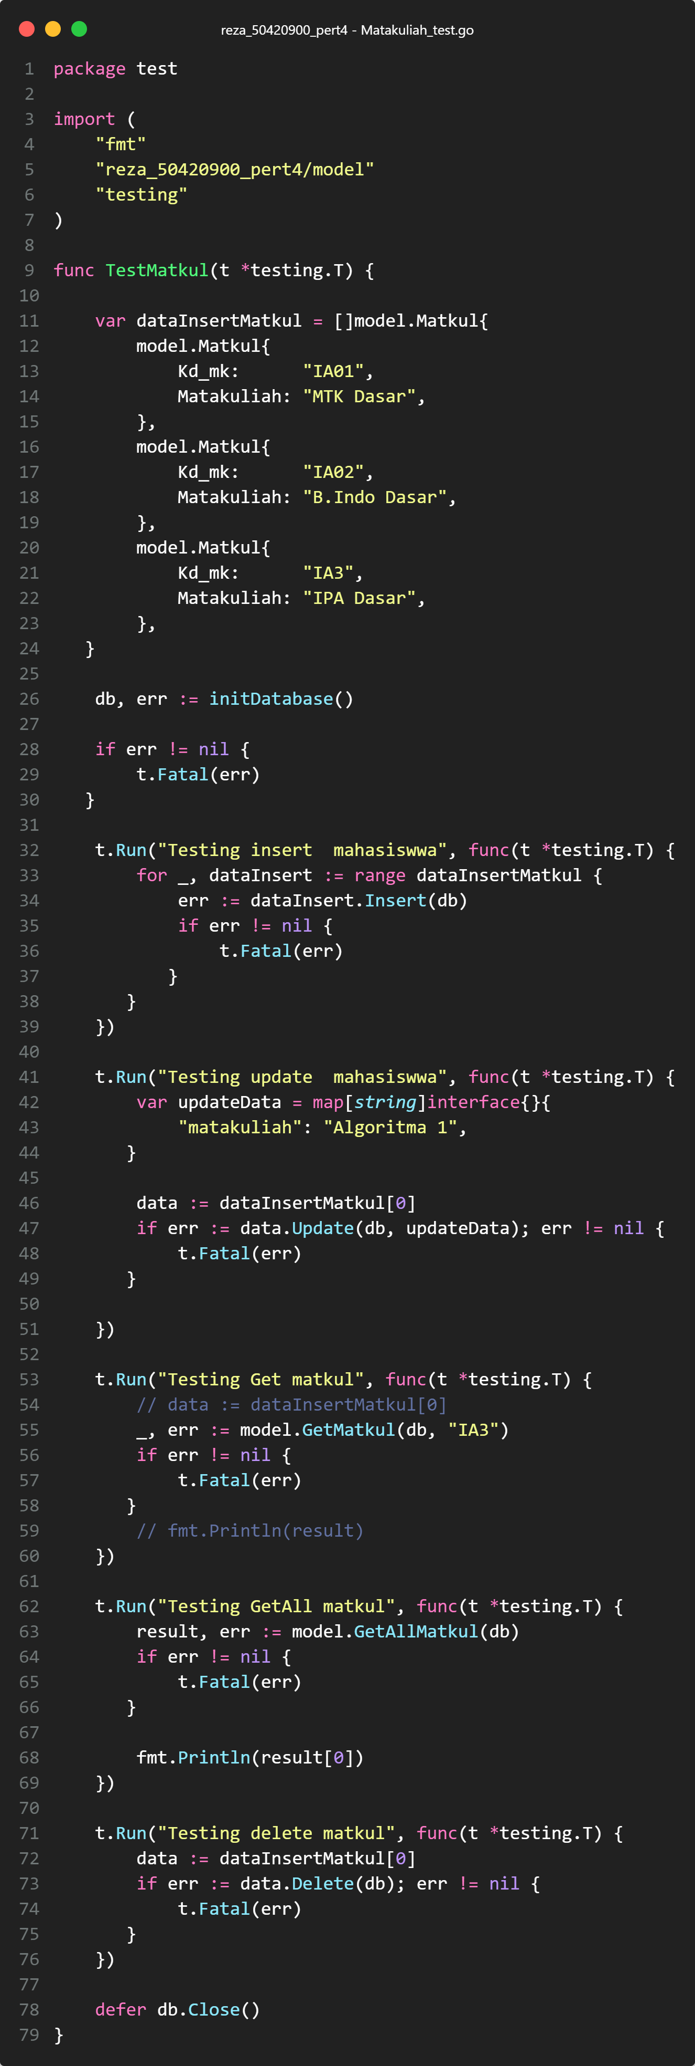

**Nilai_test.go**

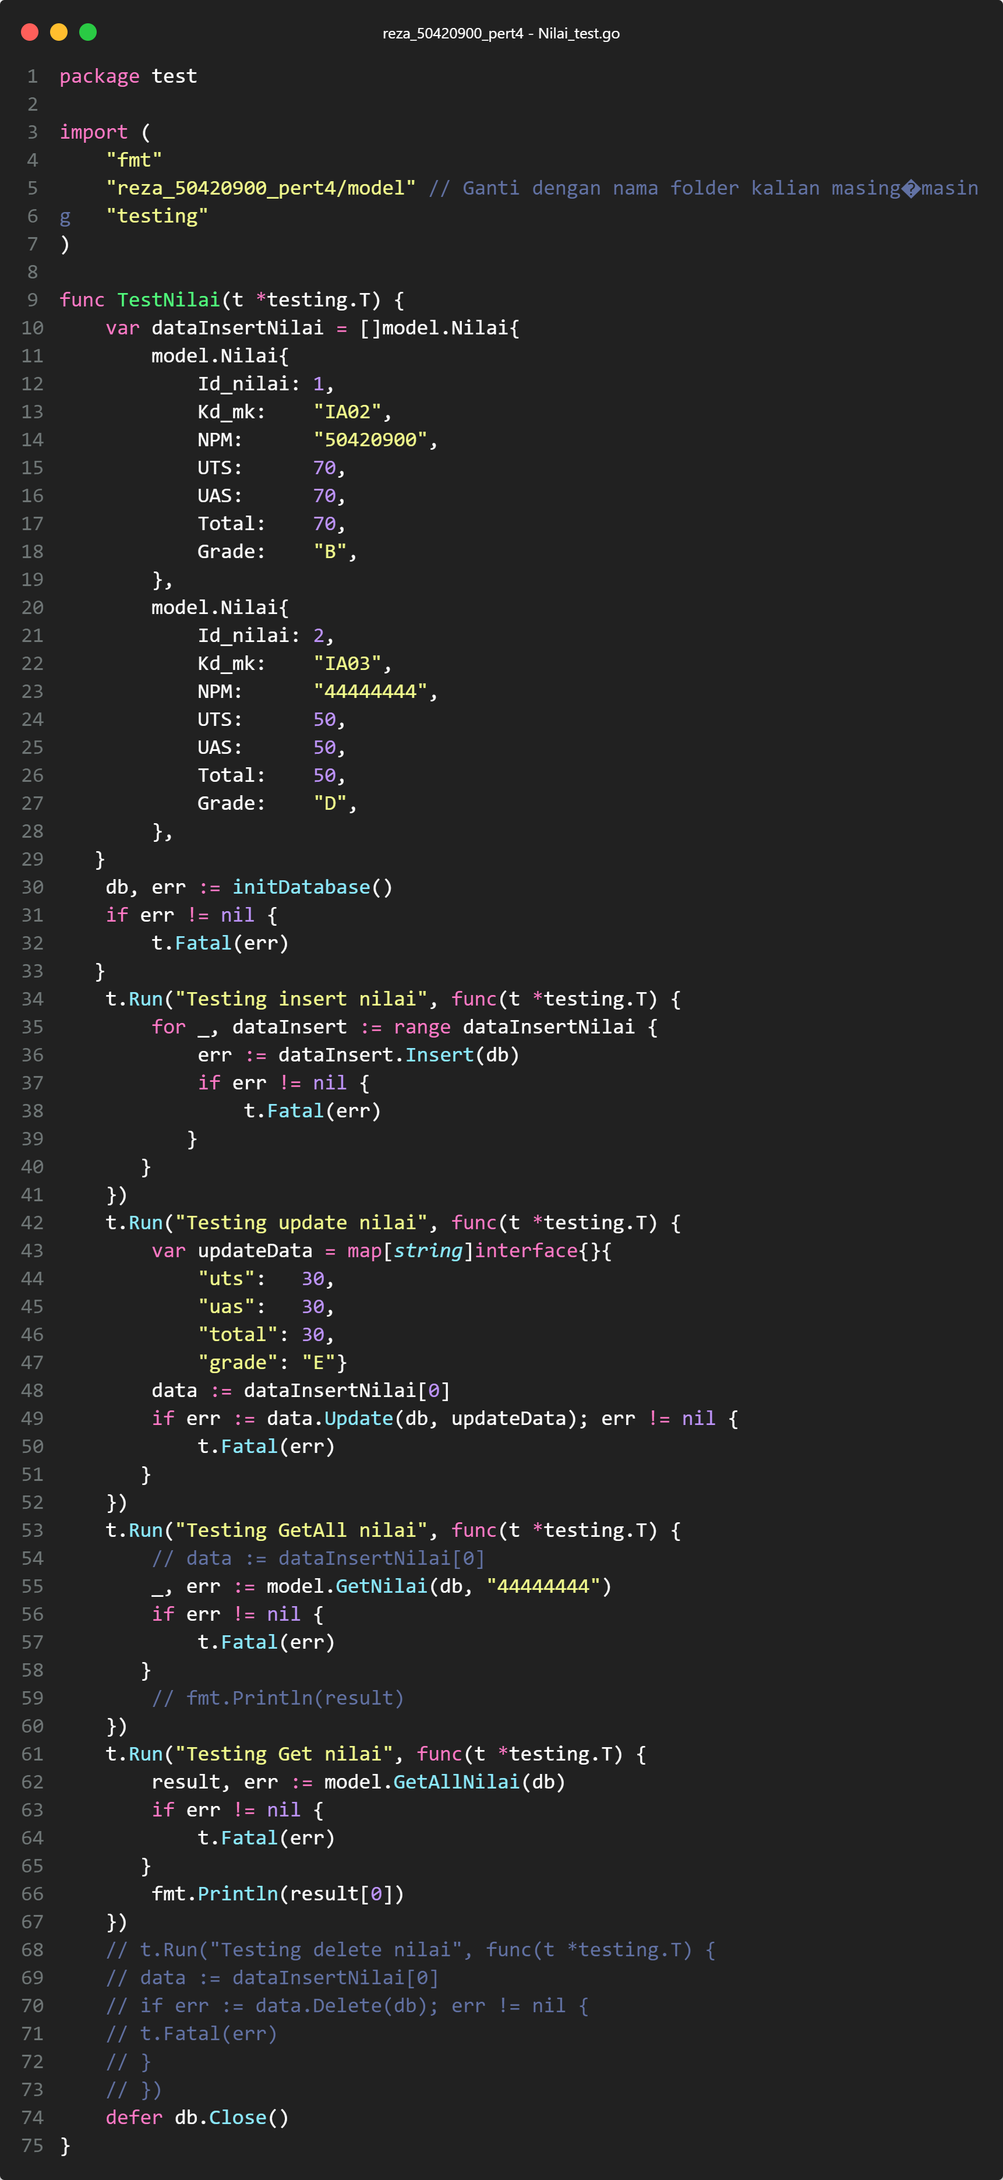

1. OUPUT PROGRAM

**Database_test.go**

go test -run TestDatabase

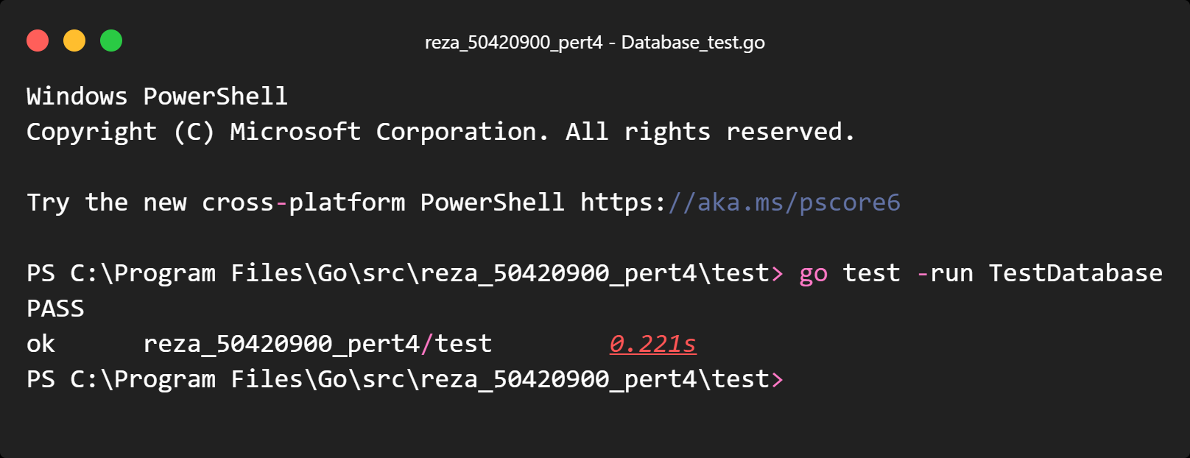

<http://localhost/phpmyadmin/>

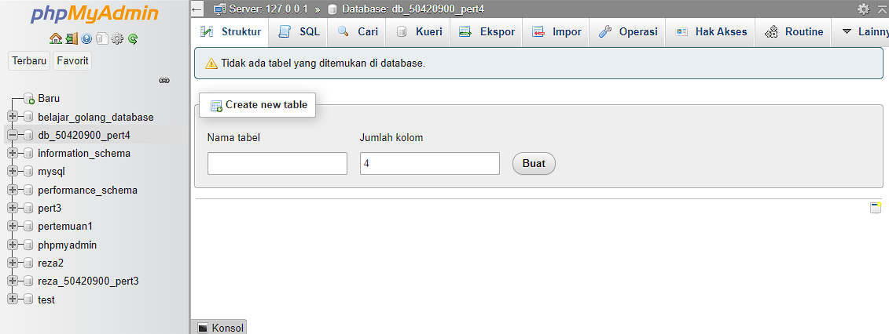

**Mahasiswa_test.go**

go test -run TestMahasiswa

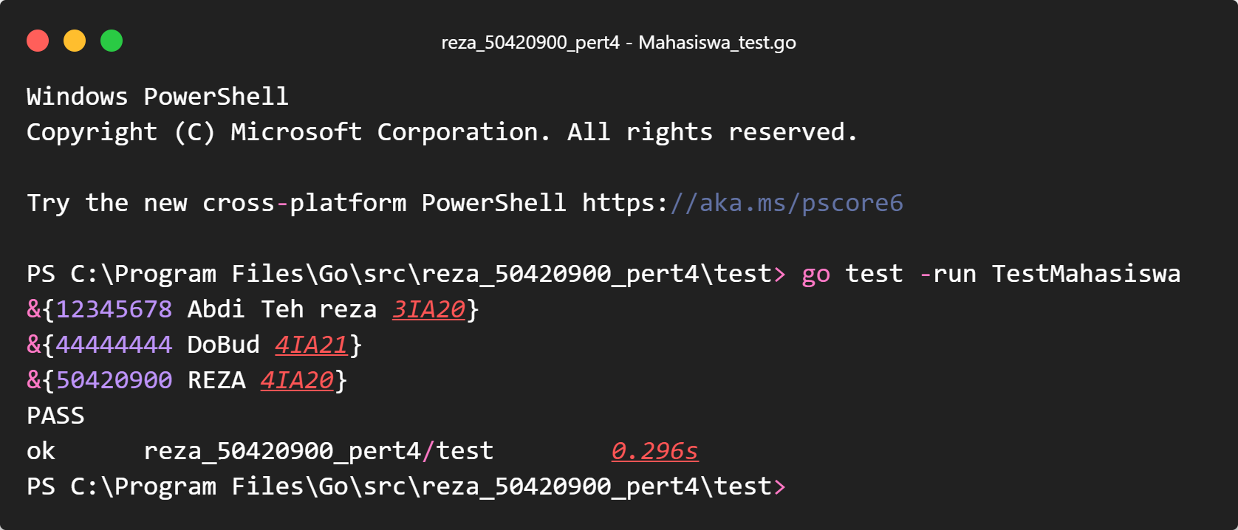

http://localhost/phpmyadmin/index.php?route=/sql&pos=0&db=db_50420900_pert4&table=mahasiswa

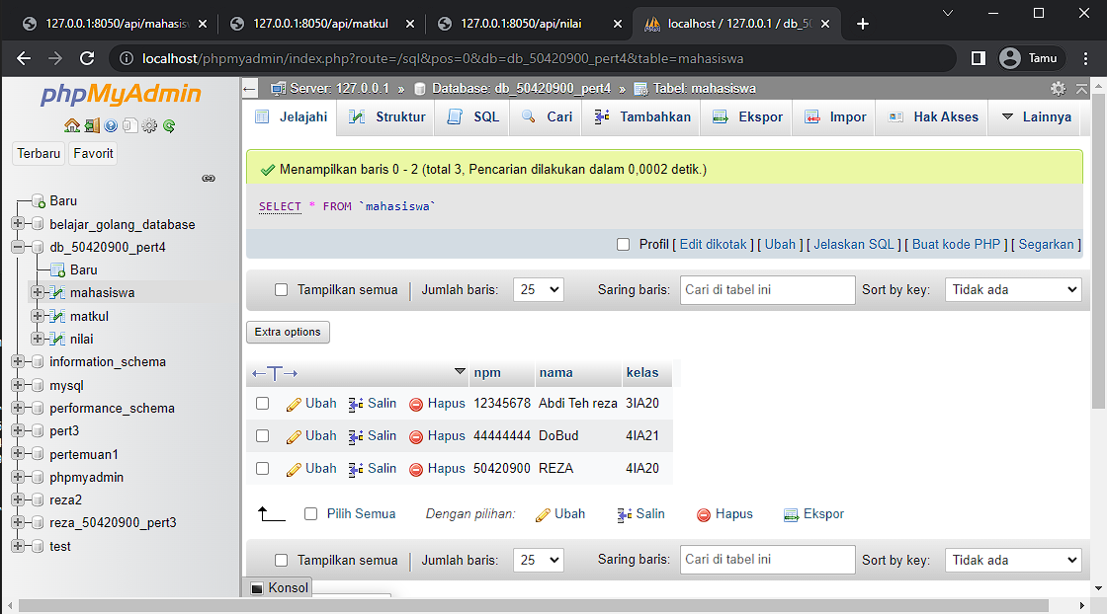

<http://127.0.0.1:8050/api/mahasiswa>

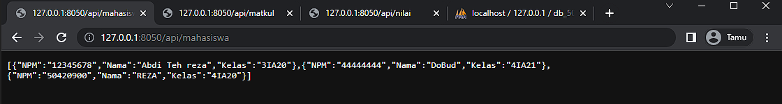

**Matakuliah_test.go**

go test -run TestMatkul

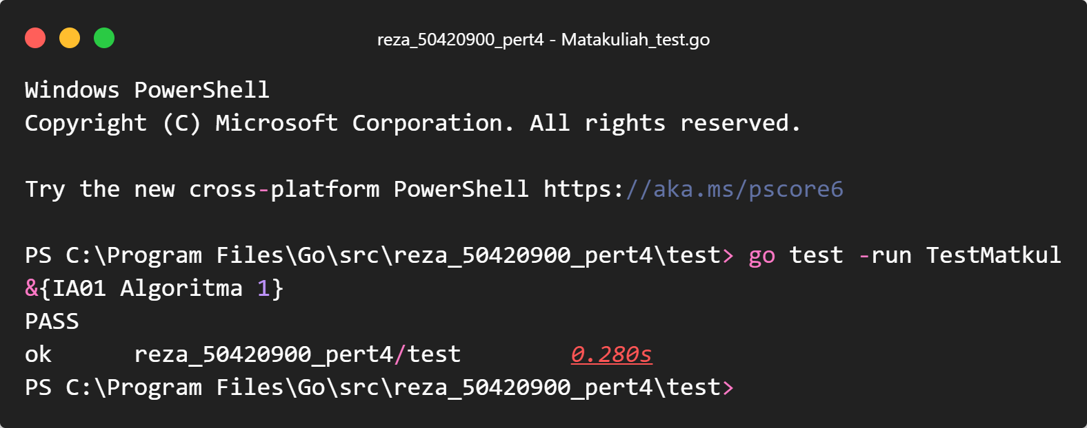

http://localhost/phpmyadmin/index.php?route=/sql&pos=0&db=db_50420900_pert4&table=matkul

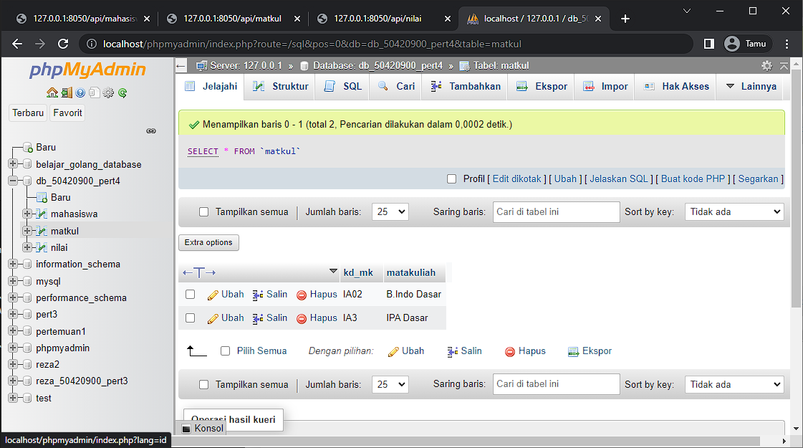

<http://127.0.0.1:8050/api/matkul>

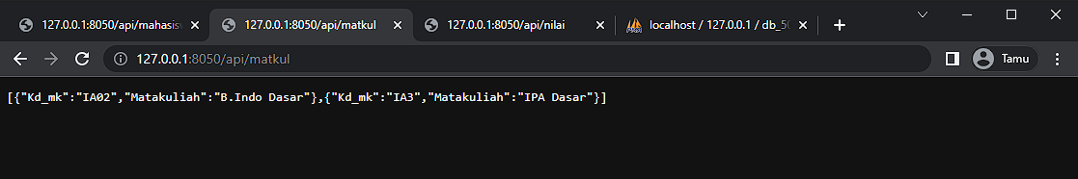

**Nilai_test.go**

go test -run TestNilai

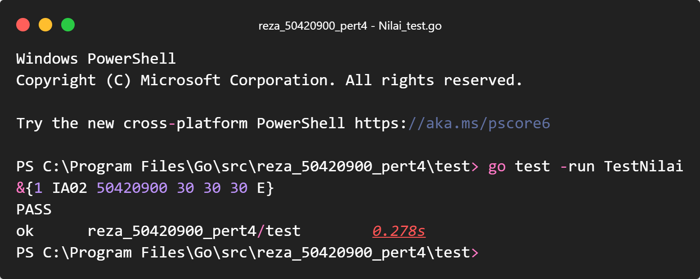

http://localhost/phpmyadmin/index.php?route=/sql&pos=0&db=db_50420900_pert4&table=nilai

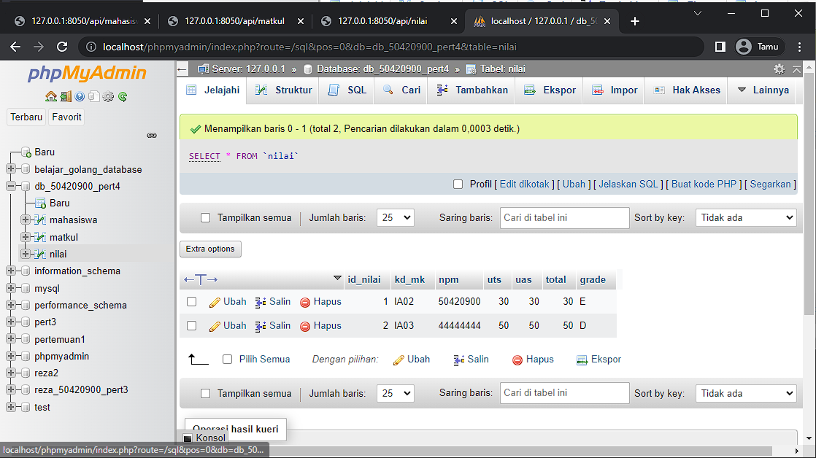

<http://127.0.0.1:8050/api/nilai>

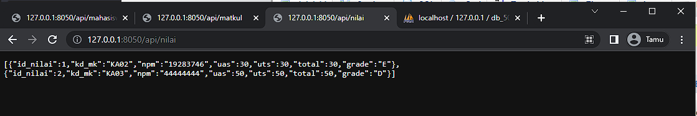

**Main.go**

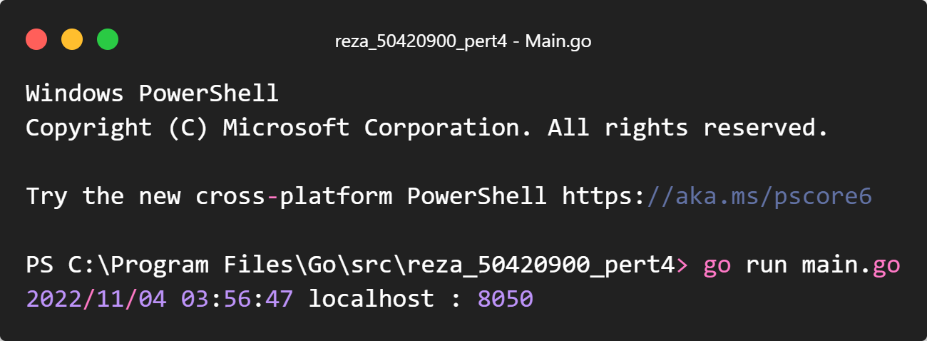

<http://127.0.0.1:8050/api/mahasiswa>



<http://127.0.0.1:8050/api/matkul>



<http://127.0.0.1:8050/api/nilai>

